MongoDB Assignment

Q.6) View list of available databases

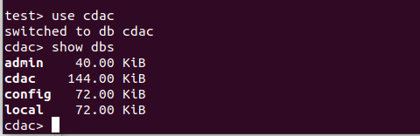

Q.7) Create a new database named CDAC and connect to it

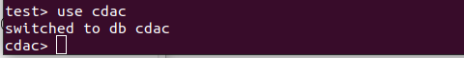

Q.8) View list of available collections in CDAC database

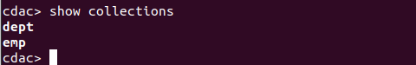

Q.9) Create a new collection by the name of LIBRARY

Q.10) Insert the following document in the LIBRARY collection:-
title:'MongoDB programming',
author:'Sameer', likes:100

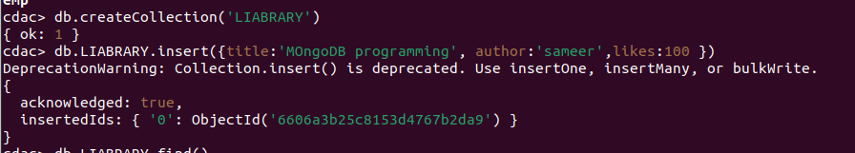

Q.11) View the recently inserted document and note the _id field

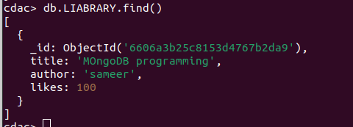

Q.12) Insert another document in the LIBRARY collection as follows:-
title:'MySQL programming',
authors:['Jack','Jill'], likes:200
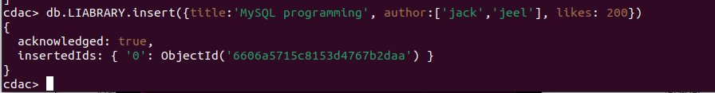

Q.13) View the inserted documents
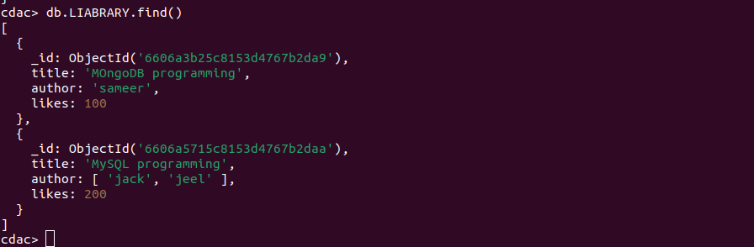

Q.14) View only the first inserted document
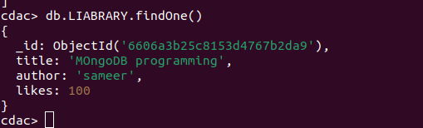

Q.15) View the documents using the pretty() method
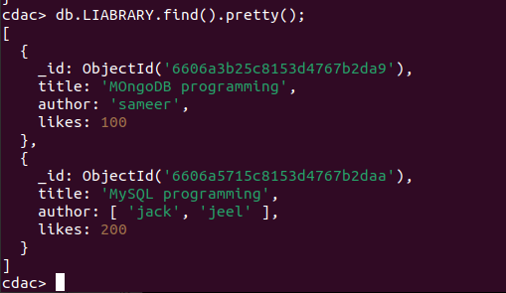

Q.16) Update the document where author name Sameer and change it to Sameer Dehadrai
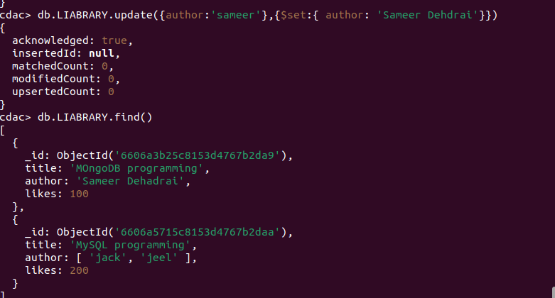

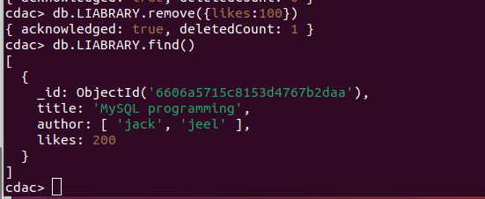
Q.17) Delete all documents that have 100 likes

